Week 9: Pipeline Creation using script
- Evaluation of Jenkins pipeline.
- WORKING ON BUILD TRIGGERS FOR LAST JENKINS PIPILINE
- Hands-on practice on creation of scripted Jenkins pipeline.
- Take the screenshots for above task

Procedure
General :
Description :- provide the description of the project
Build triggers: here we can provide with build triggers of you choice
Advance project option:
Definition:
Choose pipeline script

Here code for pipeline -script

Copy the code there
-------------------------------------------------------------------------------------------------------------------------
pipeline {
agent any
tools{
maven 'MAVEN-HOME'
}
stages {
stage('git repo & clean') {
steps {
//bat "rmdir /s /q mavenjava"
bat "git clone provide your github link"
bat "mvn clean -f mavenjava"
}
}
stage('install') {
steps {
bat "mvn install -f mavenjava" #project name#
}
}
stage('test') {
steps {
bat "mvn test -f mavenjava"
}
}
stage('package') {
steps {
bat "mvn package -f mavenjava"
}
}
}
}
Apply and save
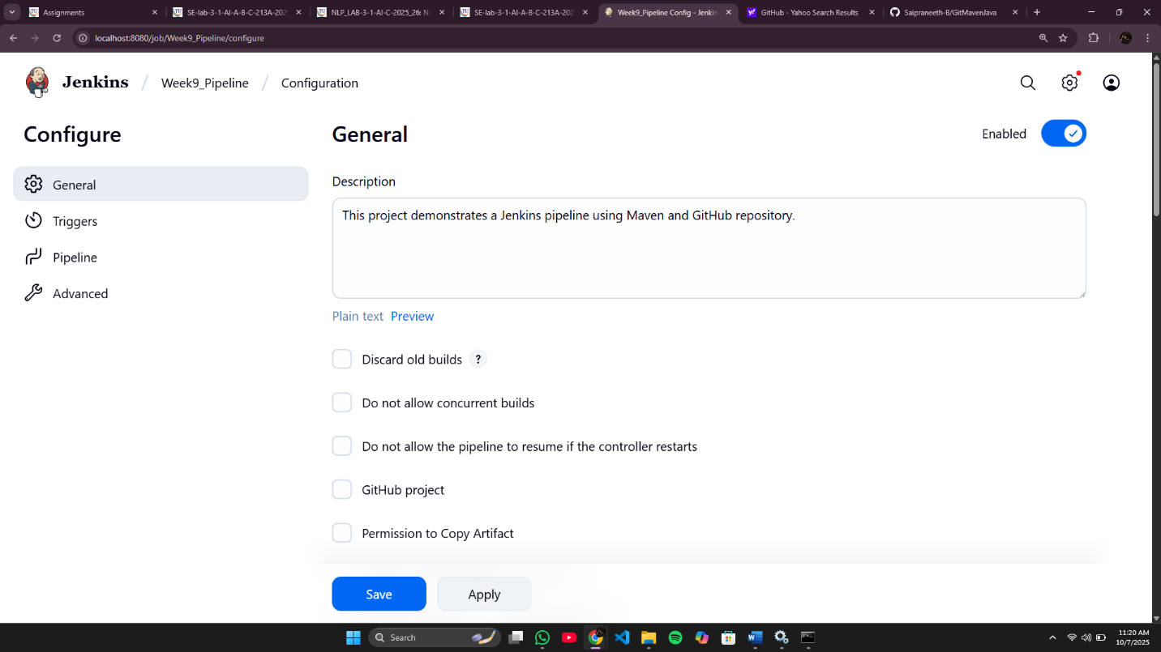

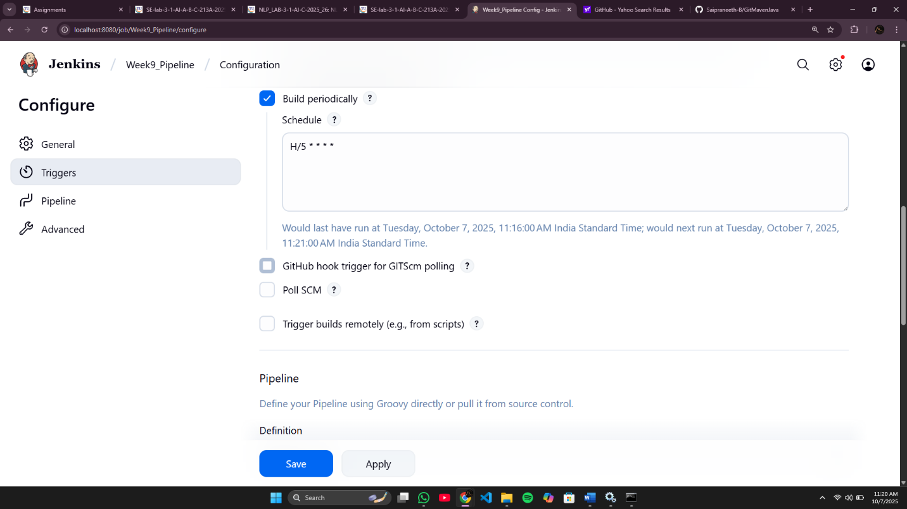

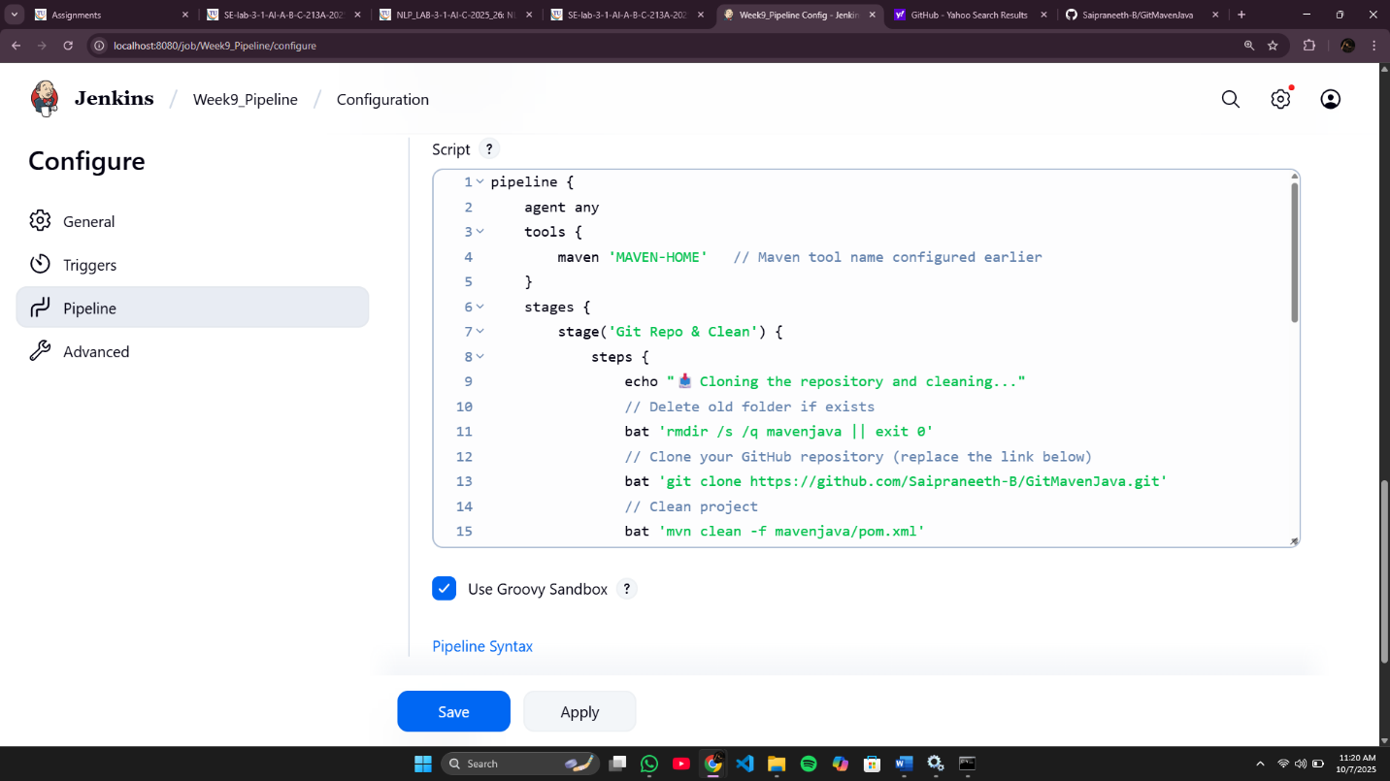

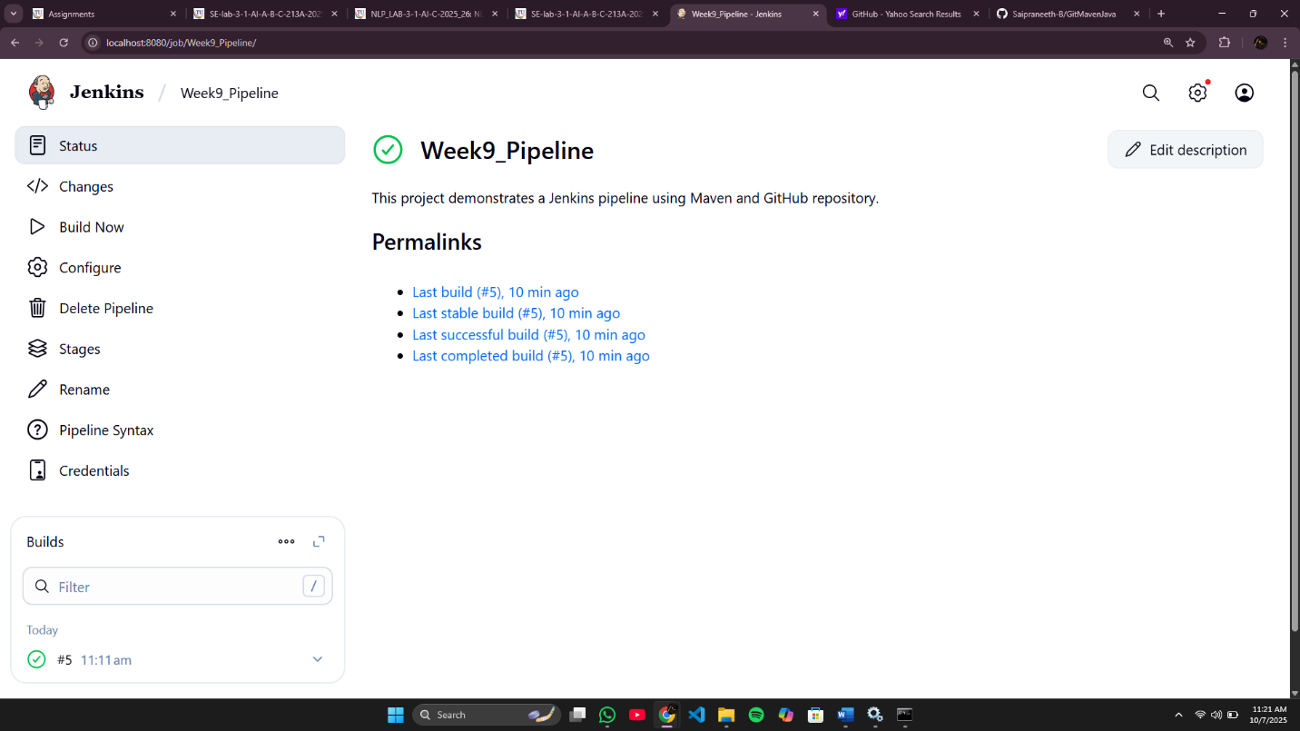

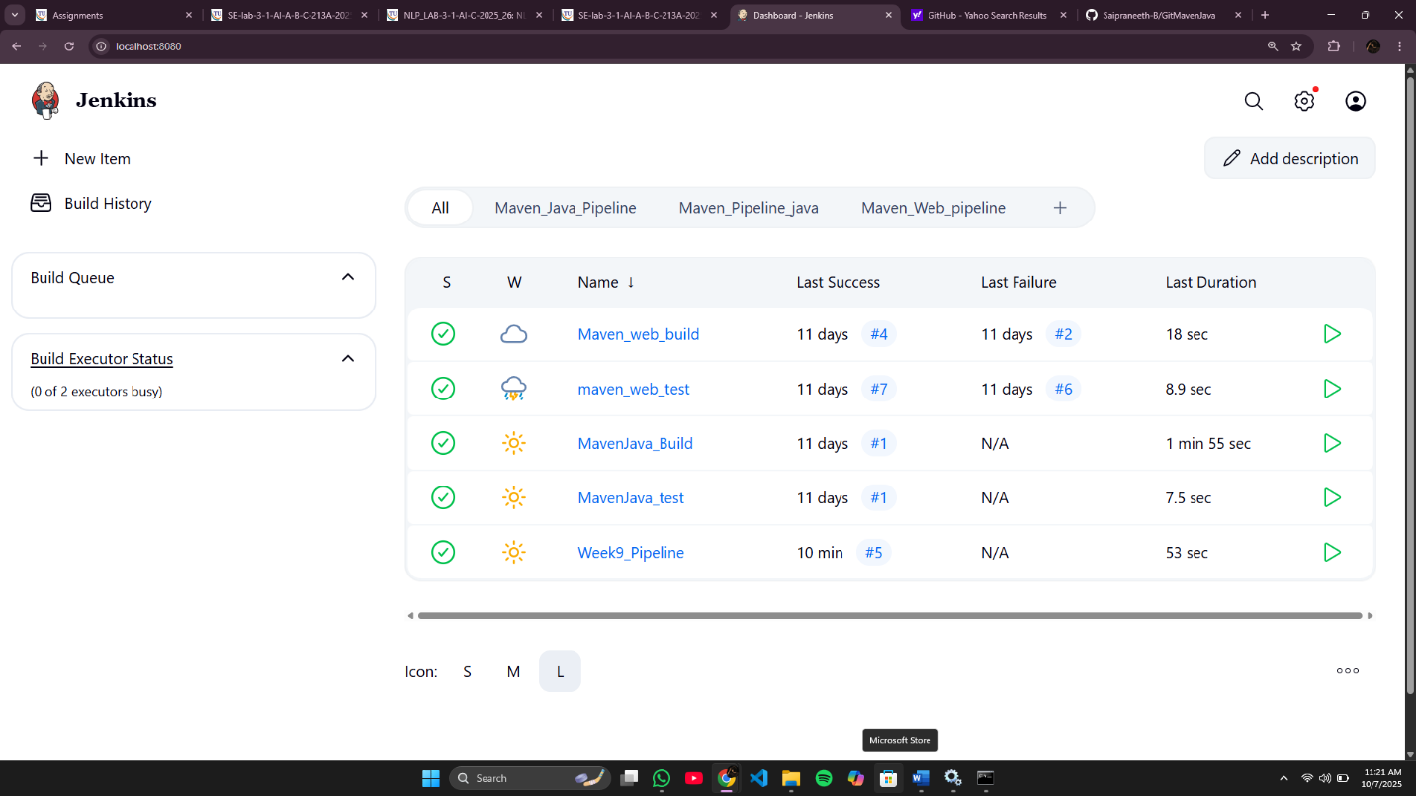

SBQ’s:
- Your manager asks you to clean the workspace before building — which stage in this pipeline takes care of it?
Ans: Git Repo & Clean
- The GitHub repository link is missing in the script — where exactly do you provide it?
Ans: git clone <url>
- If Maven is not configured globally in Jenkins, which section of the pipeline will fail first?
Ans: The pipeline will fail at the first stage (Tool Install)
- A teammate complains the pipeline is not creating .war files — which stage is responsible?
Ans: The issue is in the Package stage (it runs mvn package)
- Your test cases failed, but the pipeline still continued — how will Jenkins behave in the test stage?
Ans: Jenkins still marks the stage as failed, but next stages can run unless “stop on failure” is set.
- Instead of running nightly builds, you want this pipeline to trigger only when GitHub changes occur — where will you configure it?
Ans: Configure it in “Build Triggers → GitHub hook trigger for GITScm polling”
- If you replace mvn clean with mvn compile, what difference will it make to the project build?
Ans: It won’t delete old files. It will just compile new code.
- The project folder name is not mavenjava but studentapp — which parts of the script must you edit?
Ans: Update all paths like->mavenjava/pom.xml → studentapp/pom.xml and the rmdir / git clone lines.
- If the install stage fails, will the test and package stages still run in this pipeline?
Ans: Test and package will not run, because pipeline stages run one after another.
- A student asks where to add deployment steps to Tomcat after packaging — which is the best place in this script?
Ans: Add deployment to Tomcat → After Package stage, add a new stage called “Deploy”.
- Why is tools { maven 'MAVEN-HOME' } used in this pipeline?
Ans: It tells Jenkins which Maven version/path to use.
- If GitHub credentials are private, how can you secure them in the git repo & clean stage?
Ans: Use “Credentials” in Jenkins and add them in the Git stage like:
git credentialsId: 'your_id', url: 'repo_url'
- Which Jenkins plugin is needed to recognize the pipeline { ... } structure in this script?
Ans: Pipeline Plugin
- In Windows, the script uses bat commands — what change would you make if Jenkins runs on Linux?
Ans: Replace all bat commands with sh commands
- How will you modify the pipeline to stop execution if the GitHub clone command fails?
Your project lead asks you to print a welcome message in Jenkins to confirm the pipeline is working — how would you script it?
Ans: Add || exit 1 after the clone command so pipeline stops on error.
Example: git clone https://... || exit 1
- A teammate forgot to pull the latest GitHub code before building; how can you fix this in your pipeline?
Ans: Add a step in Git Repo & Clean stage to run: git pull origin main
- Your Java file Hello.java must be compiled every time code is committed — how will you add this step?
Ans: Add a stage with : mvn compile -f studentapp/pom.xml
- Tests should stop the pipeline if they fail — where will you put the mvn test command?
Ans: Keep mvn test inside the Test stage, Jenkins stops automatically if test fails
- Every evening at 6 PM your pipeline should run automatically — how can you set this in Jenkins?
Ans: H 18 * * *
- You only want to package the project if compilation succeeds — how would you connect the stages?
Ans: Keep Package stage after Compile stage, Jenkins runs sequentially — it won’t reach package if compile fails.
- Your professor wants a .jar file generated for submission — what pipeline stage will you add?
Ans: Use Package stage (mvn package builds the JAR file).
- A Git clone step is failing due to wrong credentials — how would you secure and use them in your script?
Ans: Store them in Jenkins Credentials and use them in : git url: 'repo_url', credentialsId: 'your_id'
- A teammate wants to see the build number inside console logs — how do you print it in the pipeline?
Ans: Use echo "Build Number: ${env.BUILD_NUMBER}" inside any stage.

